Instructions for Hands-On Assignment 3

CISC 310 – Introduction to Computer Information Science Professor Hendricks

Note: This assignment, including the readings you may need to review to help you complete it, should take you between three and five hours. When you have completed this worksheet, attach it to the corresponding Dropbox in D2L and submit your assignment.

Section A. Gather network addresses for your PC and its network environment. (16 points)
A1. Since you will type and paste all of the required information and screenshots into this document, save this document with the filename of (your last name and first initial)-HOA3-Networking.doc (e.g. HendricksR-HOA3-Networking.doc) to a storage location (e.g., your hard drive, your U: drive in the CRC Computer Lab, or a USB flash drive) from which you will be able to upload it to the appropriate Dropbox in D2L upon completion of this assignment. Save your file frequently while you are working.

A2. Type your first and last name here: Austin Smothers

A3. Using a networked personal computer (PC) at your home, at your work, or in one of the CRC Computer Labs, find the most important network addresses for that PC as listed below. You can find the following addresses through your PC’s Control Panel or at the Command Prompt. If you cannot find the information right away, you may need to use your PC’s Help and Support systems.
Where are you completing this assignment (at home, at work, in a computer lab, etc.)? | Home Computer
What is the computer’s IPv4 IP address? | 192.168.1.67
What is the computer’s IPv4 subnet mask? | 255.255.255.0
What is the IPv4 Default Gateway’s IP address? | 192.168.1.254
What is the IPv4 DHCP Server’s IP address? | 192.168.1.254
What is/are the IPv4 DNS Server’s IP address(es)? | 192.168.1.254
What is the network interface card’s physical (MAC) address? | 8C-89-A5-C5-92-95

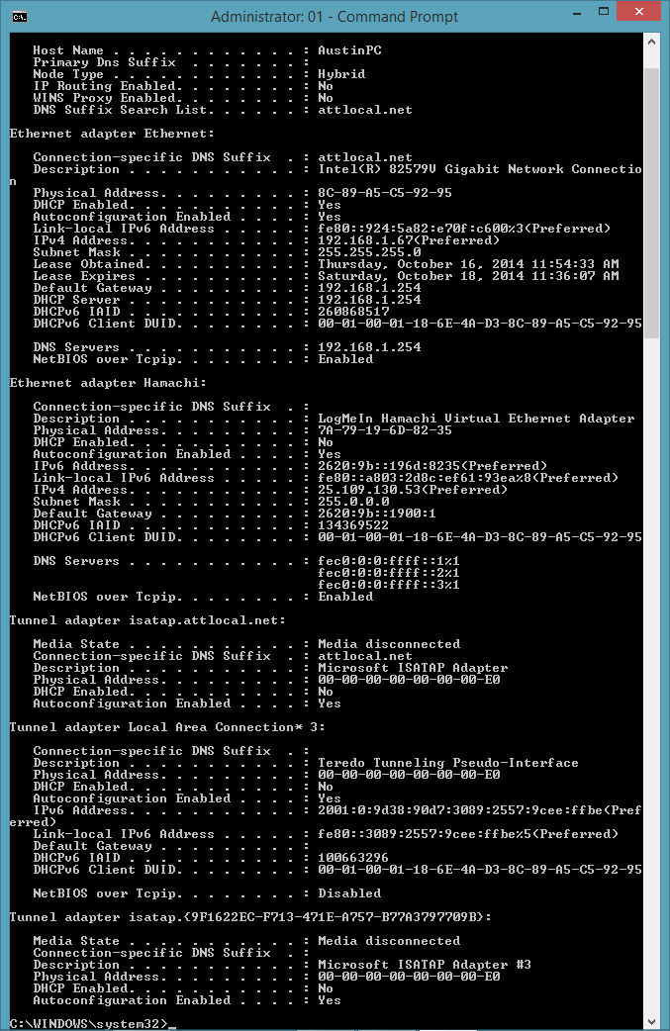
A4. Take a screenshot of the active window that displays where you found the above information (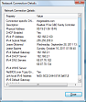 or 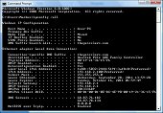; press Alt-PrtSc on your keyboard in Windows and Linux; press Command-Shift-4 in Mac OS to copy an image of the active window to the Clipboard). Paste the screenshot into this document below this paragraph.

Note: Since I cannot grade what I cannot read, please keep in mind that the text must be large enough to allow an average user to read it.
Section B. Perform basic network troubleshooting tasks with your PC. (24 points)
In this second section your task is to do some basic network troubleshooting with your PC. You will need to refer to some of the network addresses you found in Section A.

B1. Using your browser, connect to Cosumnes River College’s web server at www.crc.losrios.edu and take a screenshot of the browser window only (Press Alt-PrtSc on your keyboard in Windows and Linux; press Command-Shift-4 in Mac OS.) of CRC’s main web page. Paste the screenshot into this document below this paragraph.
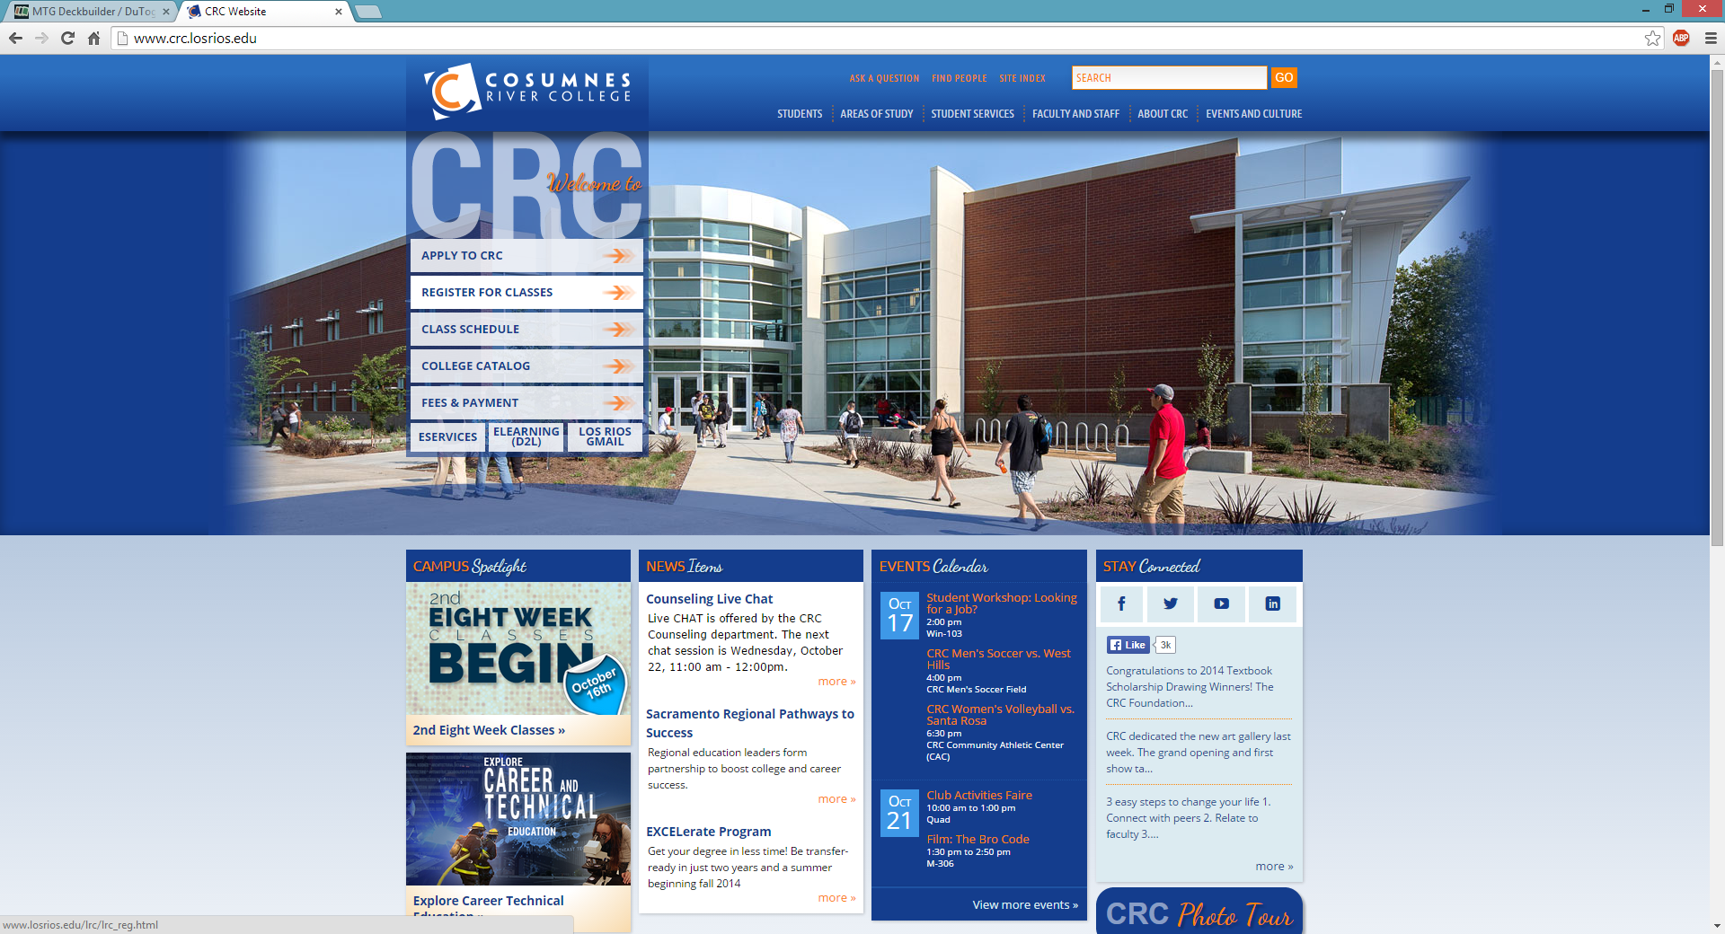
B2. Now that you know that CRC’s web server is in fact up and running, go to the Command Prompt and issue a ping command with the appropriate options/parameters to see if Cosumnes River College’s web server at www.crc.losrios.edu is responding to ping requests. Take a screenshot of the active window that displays the results of the command which appears on your screen ().Paste the screenshot into the space below.
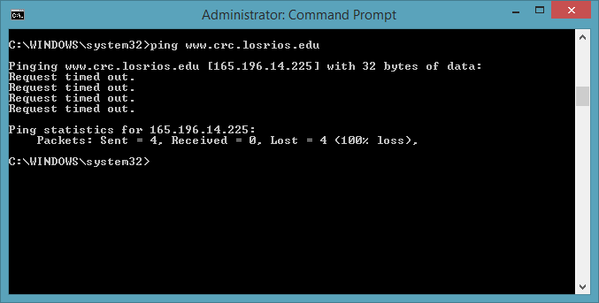
B3. Did the ping request to the CRC Web Server complete successfully? Why do you think that is? (Explain your conclusion in detail in a short paragraph below. To earn maximum credit you must use appropriate network terminology to identify the technologies involved.)
No, it did not complete the ping successfully. All four packets failed to gain a response. My theory is that the network address which I am pinging is attempting to respond to my private IPv4 address from which I am issuing the ping. When I ping the CRC website, the packet sent from my IPv4 address is routed through my ISP (which has its own public IP address for receiving info) and then to the CRC web server, which is why I can successfully send packets. In addition, when I access the website, the site's DNS recognizes my public IP address as the source of any information it is receiving, and therefore sends its information to my public IP address in response. However, when I ping from my private IPv4 address, the site's DNS fails to identify my public IP address as that address which it must send data to, and instead attempts to send its data to my IPv4 address, which it cannot do. Or at least… that's my best guess.
B4. Now issue a ping command to your computer’s IPv4 Default Gateway to verify that your router is responding to ping requests. Take a screenshot of the active window that displays the results of the command which appears on your screen (). Paste the screenshot into the space below.
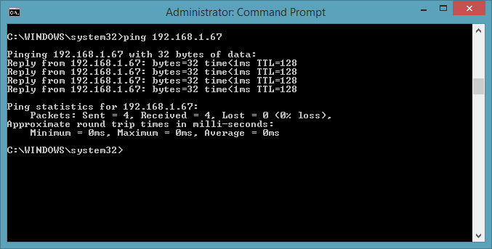

B5. Now issue a third ping command with the appropriate options/parameters to verify that Google’s web server array at www.google.com is responding to ping requests. Take a screenshot of the window that displays the results of the command which appears on your screen ().Paste the screenshot into the space below.
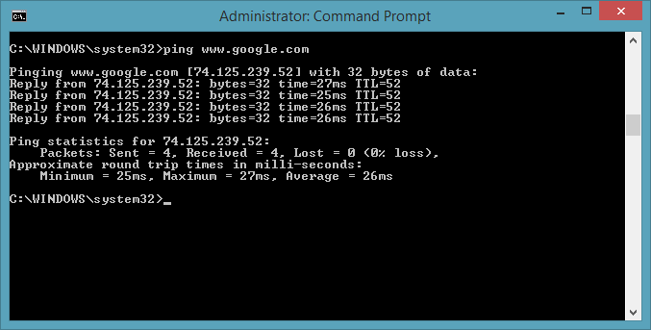
B6. Analyze the difference in the reported response times between the ping requests to your computer’s IPv4 Default Gateway and Google’s web server array at www.google.com . Why do the response times differ? (Explain your conclusion in detail in a short paragraph below. To earn maximum credit you must use appropriate network terminology to identify the technologies involved.)
The response times differ because the distance from my computer to my router is significantly smaller than the distance from my computer to Google's headquarters where their servers are set up. This means that any packet (travelling over a LAN connection) should take longer to arrive at Google's servers and then return to my computer than it would for aforementioned packet to arrive at my router and then return to my computer.
Section C. Create a basic Network Map. (10 points)
In this third section your task is to properly arrange the elements of a small business network.
Your network consists of the following devices:
Wireless Router | Cable Modem | File Server 1 | Desktop PC 1 | Desktop PC 2 | Laptop 1 | Laptop 2 | Network Printer 1 | Network Printer 2
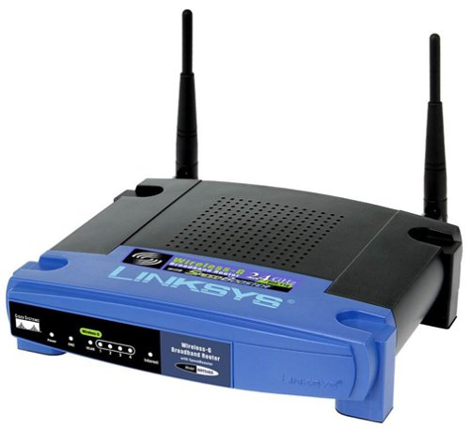 | 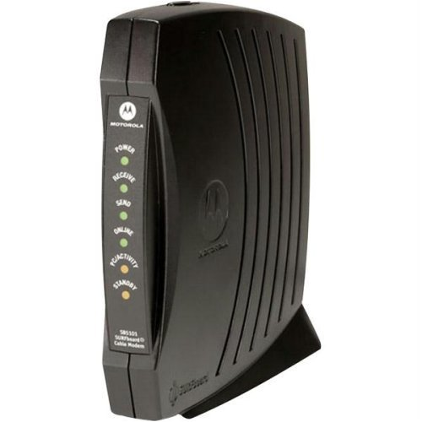 | 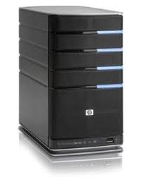 | 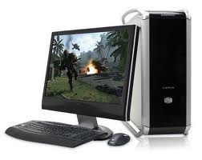 |  | 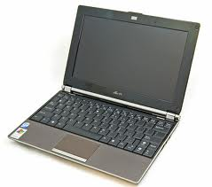 |  | 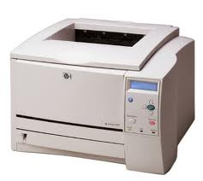

The desktop PCs and the server use wired connections, the laptops and printers use wireless connections, and you are using a cable modem connection to connect to the Internet through an ISP. Drag each of the images from the above table into the space below, arrange them as practical, and then draw lines (solid lines for wired network connections and dotted lines for wireless network connections; look for lines in the Shapes section) that reflect the topology of your network and how it connects to the Internet. Refer to your textbook for examples of similar networks.

Internet

Yes, this is a wired printer.

Note: Be sure to edit and proofread your document. I will reduce your score by 5% (2.5 points) for each spelling or grammar error.
Save your file again using the same filename you created in item 1. above, and submit this worksheet to the appropriate Dropbox in D2L.

